Experiment No: 4 Date:18.03.2021

Name:- Ranit Pradhan Roll No:- AM.EN.U4ELC19028

**BASIC OPERATION ON SIGNALS**

**AIM:**

To perform different operations on signals for both continuous and discrete case using MATLAB program.

**Lab Exercise:**

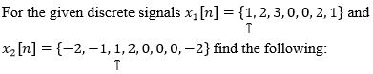

$x_{1}\left[n\right]+x_{2}[n]$

$2 x_{1}[n]$

$x_{1}\left[n\right]. x_{2}[n]$

$x_{1}\left[n\right]-x_{2}[n]$

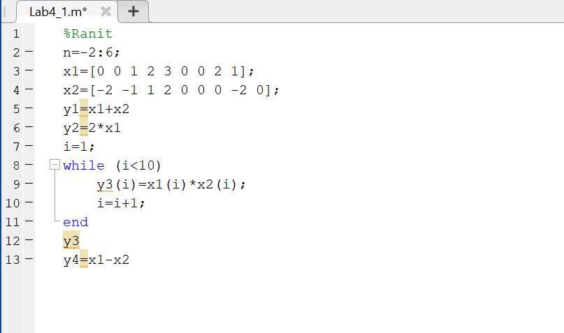

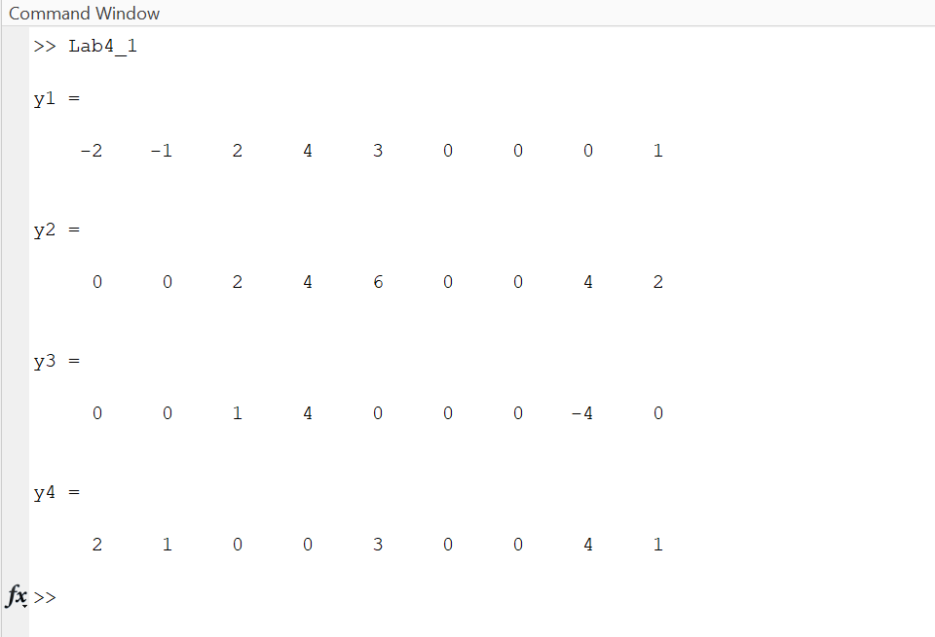

1. Write a function in MATLAB to generate the signal u(t-t0),(pass t0 as an input parameter).

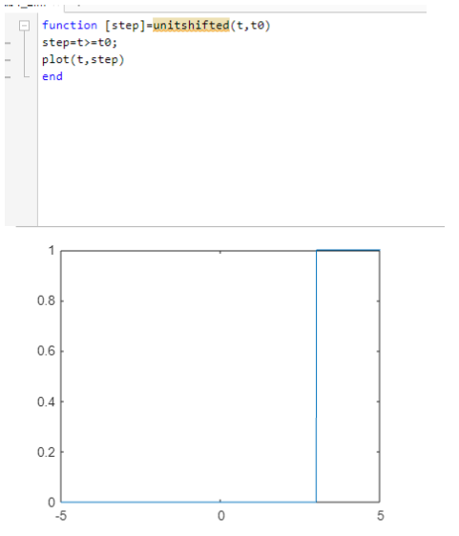

1. Use MATLAB to plot the following continuous time signals in the time interval

[-10 10].

1. δ(t+2)
2. r(t+5)

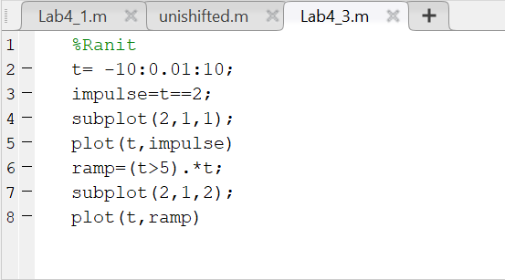

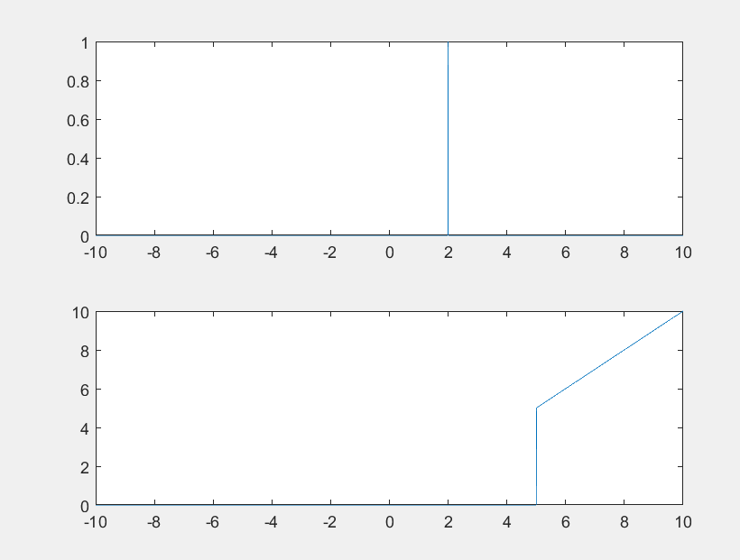

1. Plot the signals in the same figure window.

$y_{1}\left(t\right)=\sin{t}$

$y_{2}\left(t\right)=sin⁡(2t)$

$y_{3}\left(t\right)=\sin\left(5t\right)$

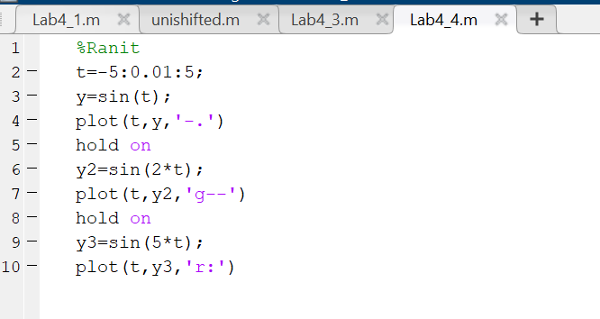

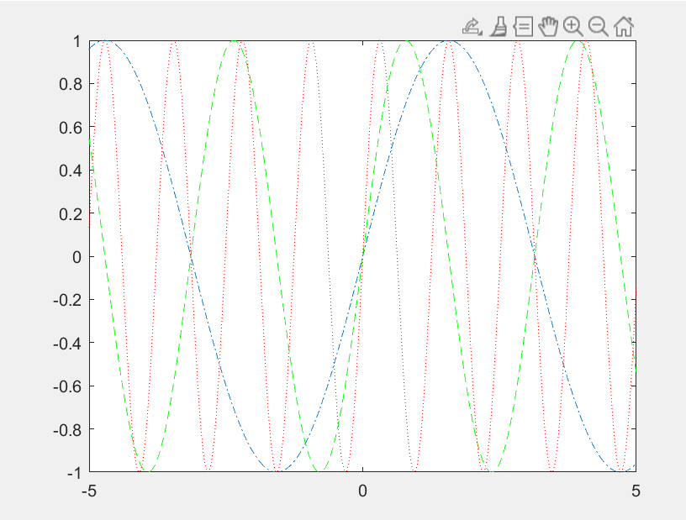

1. Plot the following discrete signals.
2. u[n-1]
3. $x\left[n\right]=\left[-2 3 0 1 5\right]$, plot $x[-n]$.
4. r[-n-1] × u[n-2]

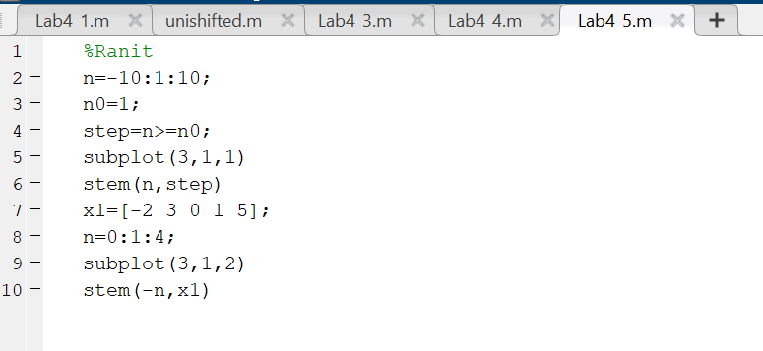

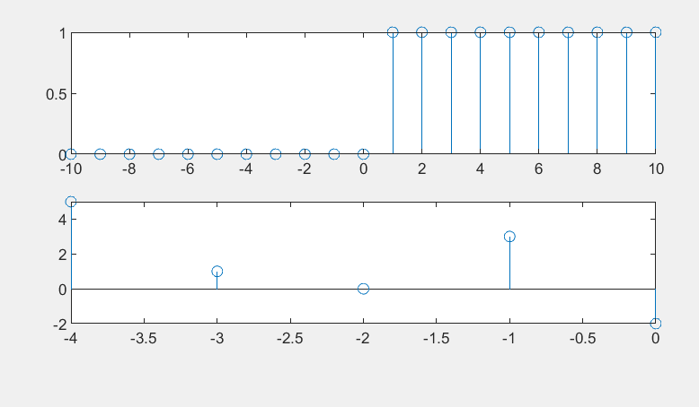

1. For the given signal $x[t]$, plot the following using MATLAB (i) x(t-3) (ii) $x(-2t+5)$

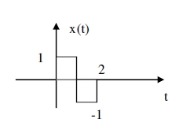

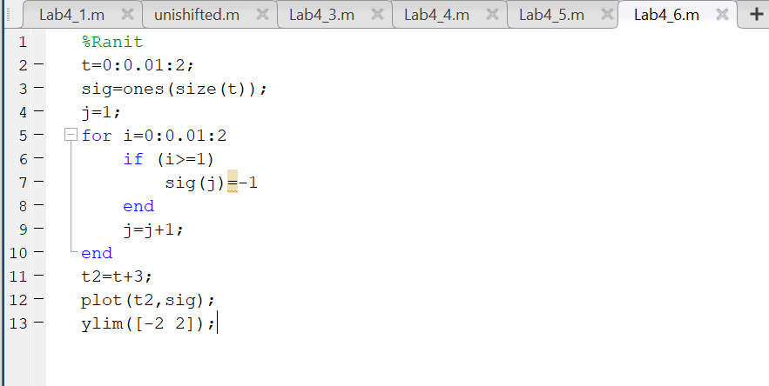

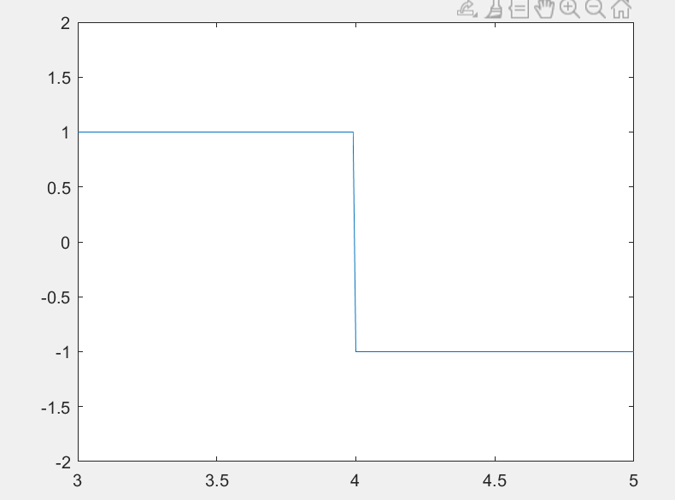

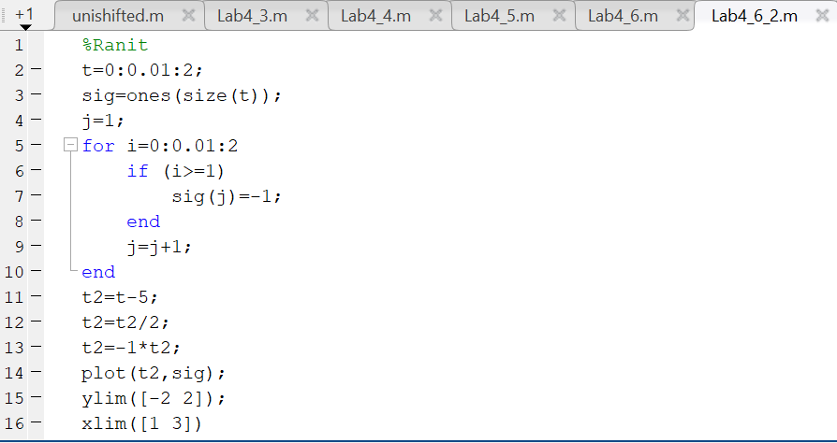

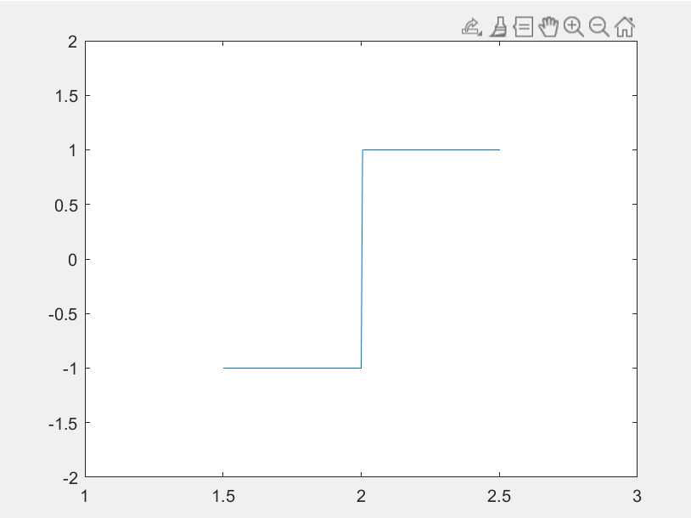

**Result:**

Different operations on signals for both continuous and discrete case using MATLAB program is coded and its screenshots are been pasted.

*****************